Experiment – 1

Aim:- To implement Linear Search and Binary search, compare and analyse its time complexities.

Code (Binary Search):-

using namespace std;

int binarySearch(int arr[], int low, int high, int x)
{
while (low <= high) {
int mid = low + (high - low) / 2;

if (arr[mid] == x)
return mid;

if (arr[mid] < x)
low = mid + 1;

else
high = mid - 1;
}

return -1;
}

int main(void)
{
int arr[] = { 10, 23, 25, 70, 11, 15 };
cout << "the array is10 23 45 70 11 15";
int x = 70;
cout << "the element we need to found is 70";
int n = sizeof(arr) / sizeof(arr[0]);
int result = binarySearch(arr, 0, n - 1, x);
if (result == -1) cout << "Element is not present in array";
else cout << "Element found at index " << result;
return 0;
}

Output:-

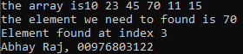

Code (Linear Search):-

#include <iostream>
using namespace std;

int linearSearch(int arr[], int n, int target) {
for (int i = 0; i < n; i++) {
if (arr[i] == target) {
return i; // Return the index if the target is found
}
}
return -1; // Return -1 if the target is not found
}

int main() {
int arr[] = { 10, 23, 45, 70, 11, 15 };
int size = sizeof(arr) / sizeof(arr[0]);
cout << "the array is";
for (int i = 0; i < size; i++) {
cout << arr[i] << " ";

}
int n = sizeof(arr) / sizeof(arr[0]);
int target = 70;
cout << endl << "the element we need to found is 70" << endl;

int result = linearSearch(arr, n, target);
if (result != -1) {
cout << "Element found at index " << result << endl;
}
else {
cout << "Element not found" << endl;
}
cout << "Abhay, 00976803122";
return 0;
}

Output:-
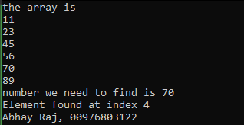

Experiment – 2

Aim:- To Implement following algorithm using array as a data structure and analyse its time complexities.

a. Insertion Sort

Code:-

#include <iostream>
#include <time.h>
#include <vector>
#include <math.h>
using namespace std;
int maxSize = 500;
enum test_c {BEST,AVERAGE,WORST};

void P_Arr(vector<int> arr) {
for (int i = 0; i < maxSize; ++i)
cout << arr[i] << " ";
cout << endl;
}
void InsSort(vector<int> &arr, int n) {
for (int i = 1; i < n; ++i) {
int key = arr[i];
int j = i - 1;
while (j >= 0 && arr[j] > key) {
arr[j + 1] = arr[j]; --j;
} arr[j + 1] = key;
}
}
vector<int> C_Arr(test_c c) {
vector<int> arr; int j = 0;
if(c == BEST)
for (int i = 0; i < maxSize; i++)
arr.push_back(i);
else if (c == WORST)
for (int i = 0; i < maxSize; ++i)
arr.push_back(maxSize - i);
else if (c == AVERAGE)
for (int i = 0; i < maxSize; ++i)
arr.push_back(rand() % maxSize);
return arr;
}
void Sort(vector<int> &arr, string arg){
clock_t start, end;
start = clock();
InsSort(arr, maxSize);
end = clock();

cout << arg << "\nTime Required: " << (end - start / CLK_TCK) << endl;
}
int main() {
vector<int> arr1 = C_Arr(BEST);
vector<int> arr2 = C_Arr(AVERAGE);
vector<int> arr3 = C_Arr(WORST);

cout << "Original array: ";
P_Arr(arr2);

Sort(arr1,"(Best Case)");
Sort(arr2, "(Average Case)");
Sort(arr3, "(Worst Case)");

cout << "Sorted array: ";
P_Arr(arr1);

cout << "Abhay Raj, 00976803122";
}

Output:-

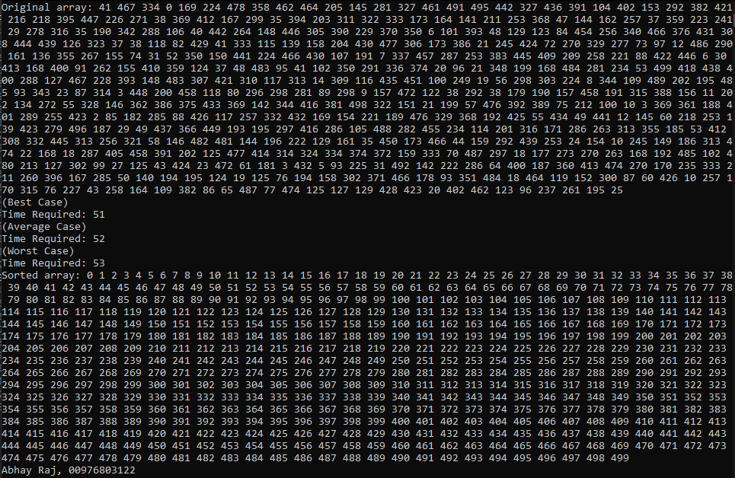

Graph:-

Best | Average | Worst | size
0 | 81 | 226 | 5000
1 | 286 | 853 | 10000
1 | 641 | 1905 | 15000
2 | 1107 | 3353 | 20000
2 | 1760 | 5285 | 25000
4 | 2577 | 7658 | 30000
4 | 3465 | 10416 | 35000

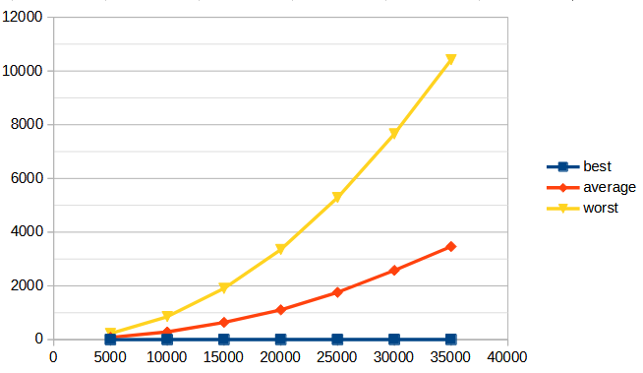

b. Bubble Sort

Code:-

#include <iostream>
#include <time.h>
#include <vector>
#include <math.h>
using namespace std;
int maxSize = 35000;
void P_Arr(vector<int> arr) {
for (int i = 0; i < maxSize; ++i)
cout << arr[i] << " ";
cout << endl;
}
void BubbleSort(vector<int>& arr) {
int n = arr.size();
for (int i = 0; i < n - 1; ++i) {
bool swapped = false;
for (int j = 0; j < n - i - 1; ++j) {
if (arr[j] > arr[j + 1]) {
swap(arr[j], arr[j + 1]);
swapped = true;
}
}if (!swapped) break;
}
}
void Sort(vector<int>& arr, string arg) {
clock_t start, end;
start = clock();
BubbleSort(arr);
end = clock();
cout << arg << "\nTime Required: " << (end - start / CLK_TCK) << endl;
}

int main() {
vector<int> arr1,arr2,arr3;
for (int i = 0; i < maxSize; i++)
arr1.push_back(i);
for (int i = 0; i < maxSize; ++i)
arr3.push_back(maxSize - i);
for (int i = 0; i < maxSize; ++i)
arr2.push_back(rand() % maxSize);

cout << "Original array: ";
P_Arr(arr2);
Sort(arr1, "(Best Case)");
Sort(arr2, "(Average Case)");
Sort(arr3, "(Worst Case)");
cout << "Sorted array: ";
P_Arr(arr1);
}

Output:-

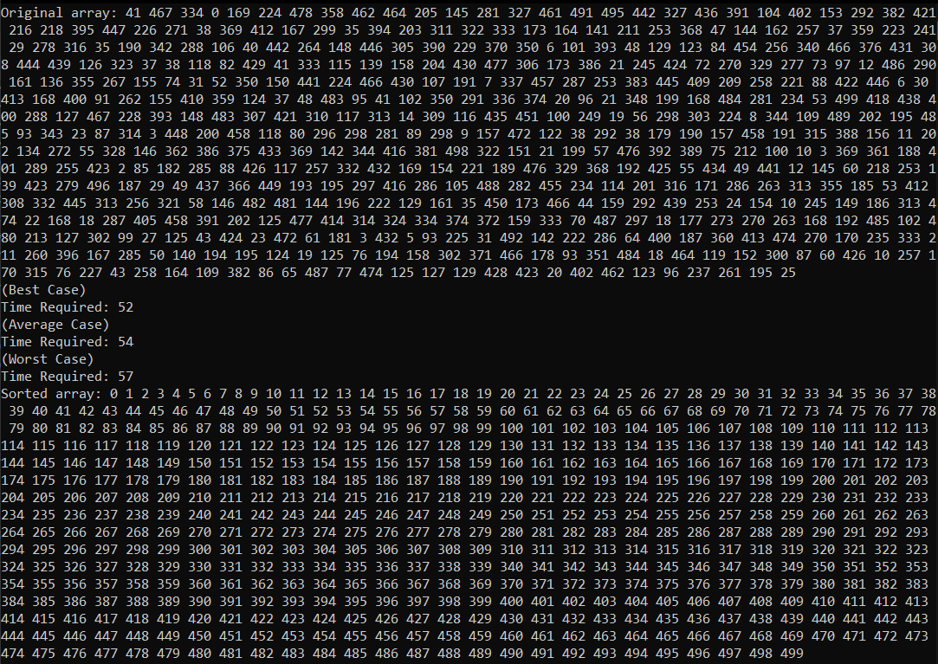

Graph:-

Best | Average | Worst | size
2 | 229 | 289 | 5000
2 | 864 | 1004 | 10000
4 | 1804 | 2294 | 15000
5 | 3144 | 3974 | 20000
5 | 4937 | 6164 | 25000
7 | 7083 | 8906 | 30000
8 | 9767 | 12232 | 35000

c. Selection Sort

Code:-

#include <iostream>
#include <vector>
#include <ctime>
using namespace std;
int maxSize = 500;
void P_Arr(const vector<int>& arr) {
for (int i = 0; i < maxSize; ++i)
cout << arr[i] << " ";
cout << endl;
}
void SelectionSort(vector<int>& arr) {
int n = arr.size();
for (int i = 0; i < n - 1; ++i) {
int minIndex = i;
for (int j = i + 1; j < n; ++j) {
if (arr[j] < arr[minIndex]) {
minIndex = j;
}
}
if (minIndex != i) {
swap(arr[i], arr[minIndex]);
}
}
}
void Sort(vector<int>& arr, const string& arg) {
clock_t start = clock();
SelectionSort(arr);
clock_t end = clock();
cout << arg << "\nTime Required: " << (end - start) / (double)CLK_TCK << " seconds" << endl;
}

int main() {
vector<int> arr1, arr2, arr3;
for (int i = 0; i < maxSize; i++)
arr1.push_back(i);
for (int i = 0; i < maxSize; ++i)
arr2.push_back(rand() % maxSize);
for (int i = 0; i < maxSize; ++i)
arr3.push_back(maxSize - i);

cout << "Original array: ";
P_Arr(arr2);
Sort(arr1, "(Best Case)");
Sort(arr2, "(Average Case)");
Sort(arr3, "(Worst Case)");
cout << "Sorted array: ";
P_Arr(arr1);

cout << "Abhay Raj, 00976803122";

return 0;
}

Output:-

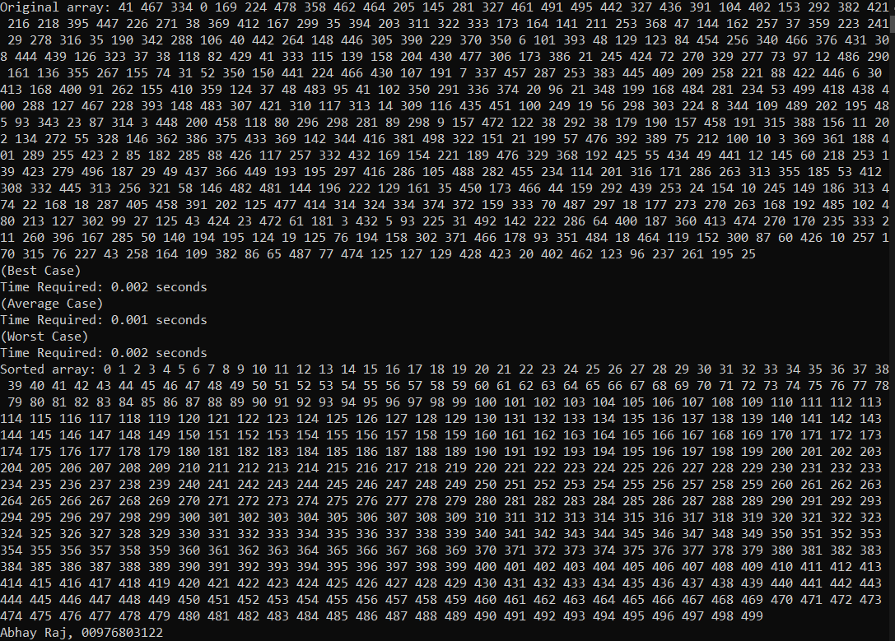

Graph:-

Best | Average | Worst | size
109 | 114 | 107 | 5000
458 | 437 | 423 | 10000
994 | 972 | 956 | 15000
1732 | 1750 | 1698 | 20000
2738 | 2710 | 2663 | 25000
3963 | 3892 | 3847 | 30000
5310 | 5365 | 5227 | 35000

d. Quick Sort

Code:-

#include <iostream>
#include <cstdlib>
#include <ctime>
#include <stack>
using namespace std;
void swap(int& a, int& b) { int temp = a; a = b; b = temp; }
int partition(int arr[], int low, int high) {
int mid = low + (high - low) / 2;
int pivot = arr[mid];
swap(arr[mid], arr[high]); int i = low - 1;
for (int j = low; j < high; j++) {
if (arr[j] < pivot) {i++;
swap(arr[i], arr[j]);
}
}swap(arr[i + 1], arr[high]);
return i + 1;
}
void qSortIter(int arr[], int l, int h) {
stack<pair<int, int>> sP;sP.push({ l, h });
while (!sP.empty()) {
pair<int, int> c = sP.top();
sP.pop();int low = c.first;
int high = c.second;
if (low < high) {
int pi = partition(arr, low, high);
if (pi - 1 - low > high - pi - 1) {
sP.push({ low, pi - 1 });
sP.push({ pi + 1, high });
}
else {
sP.push({ pi + 1, high });
sP.push({ low, pi - 1 });
}
}
}
}
void Case(int arr[], int n, const string& arg) {
clock_t start = clock();
qSortIter(arr, 0, n - 1);
clock_t end = clock();
cout << arg << "\nTime Required: " << (end - start / CLK_TCK) << endl;
}
int main() {
int n = 35000;
int* arr1 = new int[n], * arr2 = new int[n], * arr3 = new int[n];
for (int i = 0; i < n; i++) arr1[i] = i, arr2[i] = n - i, arr3[i] = rand();
Case(arr1, n, "Best");
Case(arr2, n, "Average");
Case(arr3, n, "Worst");
}
Output:-

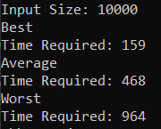

Graph:-

Best | Average | Worst | size
4 | 4 | 5 | 10000
26 | 30 | 29 | 50000
54 | 48 | 70 | 100000
229 | 217 | 384 | 500000
449 | 429 | 758 | 1000000
2314 | 2231 | 4204 | 5000000
4511 | 4491 | 9166 | 10000000

e. Merge Sort

Code:-

#include <iostream>
#include <cstdlib>
#include <ctime>
#include <stack>
using namespace std;
int n = 5000;
void merge(int arr[], int l, int m, int r) {
int n1 = m - l + 1;
int n2 = r - m;
int* L = new int[n1];
int* R = new int[n2];
for (int i = 0; i < n1; i++)
L[i] = arr[l + i];
for (int j = 0; j < n2; j++)
R[j] = arr[m + 1 + j];
int i = 0, j = 0, k = l;
while (i < n1 && j < n2) {
if (L[i] <= R[j]) {arr[k] = L[i];i++;}
else {arr[k] = R[j];j++;}k++;}
while (i < n1) {arr[k] = L[i];i++;k++;}
while (j < n2) {arr[k] = R[j];j++;k++;}
}

void mSort(int arr[], int l, int r) {
if (l < r) {
int mid = l + (r - l) / 2;
mSort(arr, l, mid);
mSort(arr, mid + 1, r);
merge(arr, l, mid, r);
}
}

void analyzeCase(int arr[], const string& arg) {
clock_t start = clock();
mSort(arr, 0, n - 1);
clock_t end = clock();
cout << arg << "\nTime Required: " << (end - start / CLK_TCK) << endl;

}
int main() {
cout << "Input Size:- " << n << endl;
int* arr1 = new int[n], * arr2 = new int[n], * arr3 = new int[n];
for (int i = 0; i < n; i++) arr1[i] = i, arr2[i] = n - i, arr3[i] = rand();
analyzeCase(arr1, "Best Case");
analyzeCase(arr2, "Average Case");
analyzeCase(arr3, "Worst Case");
cout << "Abhay Raj, 00976803122";
}

Output:-

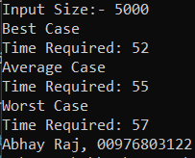

Graph:-

Best | Average | Worst | size
4 | 4 | 5 | 10000
19 | 20 | 22 | 50000
38 | 47 | 44 | 100000
241 | 237 | 188 | 500000
445 | 463 | 378 | 1000000
1973 | 2110 | 1908 | 5000000
3996 | 4012 | 3853 | 10000000

e. Heap Sort

Code:-

#include <iostream>
#include <cstdlib>
#include <ctime>
int n = 5000;
using namespace std;

void hpy(int arr[], int n, int i) {
int lg = i;
int l = 2 * i + 1;
int r = 2 * i + 2;

if (l < n && arr[l] > arr[lg])lg = l;
if (r < n && arr[r] > arr[lg])lg = r;
if (lg != i) { swap(arr[i], arr[lg]); hpy(arr, n, lg); }
}

void heapSort(int arr[], int n) {
for (int i = n / 2 - 1; i >= 0; i--)hpy(arr, n, i);
for (int i = n - 1; i > 0; i--) {swap(arr[0], arr[i]);
hpy(arr, i, 0);}
}

void analyzeCase(int arr[], const string& arg) {
clock_t start = clock();
heapSort(arr, n);
clock_t end = clock();
cout << arg << "\nTime Required: " << (end - start / CLK_TCK) << endl;
}

int main() {
cout << "Input Size: " << n << endl;
int* arr1 = new int[n], * arr2 = new int[n], * arr3 = new int[n];
for (int i = 0; i < n; i++) arr1[i] = i, arr2[i] = n - i, arr3[i] = rand();
analyzeCase(arr1, "Best");
analyzeCase(arr2, "Average");
analyzeCase(arr3, "Worst");
}

Output:-

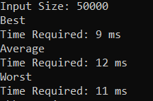

Graph:-

Best | Average | Worst | size
1 | 2 | 1 | 10000
9 | 12 | 11 | 50000
20 | 22 | 20 | 100000
122 | 152 | 133 | 500000
261 | 301 | 230 | 1000000
1332 | 1385 | 1267 | 5000000
2768 | 2988 | 2636 | 10000000

Experiment – 3

Aim:- To implement Strassen’s algorithm for Matrix Multiplication and analyse its time
complexity.

Code:-

#include <iostream>
#include <vector>
using namespace std;
using V = vector<int>;
using VV = vector<V>;
VV add(const VV& A, const VV& B) {
int n = A.size();
VV R(n, V(n));
for (int i = 0; i < n; ++i)
for (int j = 0; j < n; ++j)
R[i][j] = A[i][j] + B[i][j];
return R;
}
VV sub(const VV& A, const VV& B) {
int n = A.size();
VV R(n, V(n));
for (int i = 0; i < n; ++i)
for (int j = 0; j < n; ++j)
R[i][j] = A[i][j] - B[i][j];
return R;
}
VV strassen(const VV& A, const VV& B) {
int n = A.size();
if (n == 1) return { {A[0][0] * B[0][0]} };

int sz = n / 2;
VV A11(sz, V(sz)), A12(sz, V(sz)), A21(sz, V(sz)), A22(sz, V(sz));
VV B11(sz, V(sz)), B12(sz, V(sz)), B21(sz, V(sz)), B22(sz, V(sz));

for (int i = 0; i < sz; i++)
for (int j = 0; j < sz; j++) {
A11[i][j] = A[i][j]; A12[i][j] = A[i][j + sz];
A21[i][j] = A[i + sz][j]; A22[i][j] = A[i + sz][j + sz];
B11[i][j] = B[i][j]; B12[i][j] = B[i][j + sz];
B21[i][j] = B[i + sz][j]; B22[i][j] = B[i + sz][j + sz];
}

auto M1 = strassen(add(A11, A22), add(B11, B22));
auto M2 = strassen(add(A21, A22), B11);
auto M3 = strassen(A11, sub(B12, B22));
auto M4 = strassen(A22, sub(B21, B11));
auto M5 = strassen(add(A11, A12), B22);
auto M6 = strassen(sub(A21, A11), add(B11, B12));
auto M7 = strassen(sub(A12, A22), add(B21, B22));

VV C(n, V(n));
for (int i = 0; i < sz; i++) {
for (int j = 0; j < sz; j++) {
C[i][j] = M1[i][j] + M4[i][j] - M5[i][j] + M7[i][j];
C[i][j + sz] = M3[i][j] + M5[i][j];
C[i + sz][j] = M2[i][j] + M4[i][j];
C[i + sz][j + sz] = M1[i][j] - M2[i][j] + M3[i][j] + M6[i][j];
}
}

return C;
}
void print(const VV& M) {
for (const auto& r : M) {
for (int v : r) cout << v << " ";
cout << endl;
}
}
int main() {
VV A = { {1, 2, 3, 4}, {5, 6, 7, 8}, {9, 10, 11, 12}, {13, 14, 15, 16} };
VV B = { {16, 15, 14, 13}, {12, 11, 10, 9}, {8, 7, 6, 5}, {4, 3, 2, 1} };
cout << "Matrix A:" << endl;
print(A);
cout << "\nMatrix B:" << endl;
print(B);
VV C = strassen(A, B);
cout << "\nResult of Strassen's Matrix Multiplication (A * B):" << endl;
print(C);
}

Output:-

Matrix A:
1 2 3 4
5 6 7 8
9 10 11 12
13 14 15 16

Matrix B:
16 15 14 13
12 11 10 9
8 7 6 5
4 3 2 1

Result of Strassen's Matrix Multiplication (A * B):
80 70 60 50
240 214 188 162
400 358 316 274
560 502 444 386

Abhay Raj, 00976803122

Graph:-

Not Applicable.
Experiment – 4

Aim:- To implement Activity Selection problem and analyse its time complexity.

Code:-

#include <iostream>
#include <vector>
#include <algorithm>
using namespace std;

struct A { int s, e; };
bool cmp(A a, A b) { return a.e < b.e; }

int maxAct(vector<A>& a) {
sort(a.begin(), a.end(), cmp);
int cnt = 1, end = a[0].e;
for (int i = 1; i < a.size(); i++) {
if (a[i].s >= end) cnt++, end = a[i].e;
}
return cnt;
}

int main() {
vector<A> a = { {1, 2}, {3, 4}, {0, 6}, {5, 7}, {8, 9}, {5, 9} };
cout << "Max activities: " << maxAct(a) << endl;
}

Output:-

Max activities: 4
Abhay Raj, 00976803122

Graph:-

Not Applicable.
Experiment – 5

Aim:- To implement Task Scheduling problem and analyse its time complexity.

Code:-

#include <iostream>
#include <vector>
#include <algorithm>
using namespace std;

struct Task { int id, d, p; };
bool cmp(Task a, Task b) { return a.p > b.p; }

int maxProfit(vector<Task>& tasks, int maxD) {
sort(tasks.begin(), tasks.end(), cmp);
vector<int> slot(maxD + 1, -1); int profit = 0;
for (auto& t : tasks) {
for (int j = min(maxD, t.d); j > 0; j--) {
if (slot[j] == -1) { slot[j] = t.id; profit += t.p; break; }
}
}
return profit;
}

int main() {
vector<Task> tasks = { {1, 2, 100}, {2, 1, 50}, {3, 2, 200}, {4, 1, 20}, {5, 3, 150} };
cout << "Max Profit: " << maxProfit(tasks, 3) << endl;
}

Output:-

Max Profit : 450
Abhay Raj, 00976803122

Graph:-

Not Applicable.
Experiment – 6

Aim:- To implement Huffman Coding and analyse its time complexity.

Code:-

#include <iostream>
#include <queue>
#include <unordered_map>
#include <vector>
using namespace std;

struct N { char c; int f; N* l, * r;
N(char x, int y) : c(x), f(y), l(nullptr), r(nullptr) {} };
struct C { bool operator()(N* a, N* b)
{ return a->f > b->f; } };

void gen(N* n, string s, unordered_map<char, string>& h) {
if (!n) return;
if (!n->l && !n->r) h[n->c] = s;
gen(n->l, s + "0", h);
gen(n->r, s + "1", h);
}

void huff(string t) {
unordered_map<char, int> f;
for (char c : t) f[c]++;

priority_queue<N*, vector<N*>, C> q;
for (auto& p : f) q.push(new N(p.first, p.second));

while (q.size() > 1) {
N* l = q.top(); q.pop();
N* r = q.top(); q.pop();
N* m = new N('$', l->f + r->f);
m->l = l; m->r = r;
q.push(m);
}

unordered_map<char, string> h;
gen(q.top(), "", h);

for (auto& p : h) cout << p.first << ": " << p.second << endl;
}

int main() {
string t = "this is an example for huffman encoding";
huff(t);
return 0;
}

Output:-

n: 000
h: 0010
s: 0011
d: 01011
l: 01001
t: 01000
m: 0110
u: 01010
r: 01110
g: 01111
x: 10000
p: 10001
c: 10010
o: 10011
f: 1010
e: 1011
: 110
a: 1110
i: 1111
Abhay Raj, 00976803122

Graph:-

Not Applicable.
Experiment – 7

Aim:- To implement Fractional Knapsack problem and analyse its time complexity

Code:-

#include <iostream>
#include <vector>
#include <algorithm>
using namespace std;

struct I { int v, w; double r; I(int x, int y) : v(x), w(y), r((double)x / y) {} };
bool cmp(I a, I b) { return a.r > b.r; }

double ks(vector<I>& itms, int W) {
sort(itms.begin(), itms.end(), cmp);
double t = 0;
for (auto& i : itms) {
if (W == 0) break;
if (i.w <= W) { t += i.v; W -= i.w; }
else { t += i.v * ((double)W / i.w); break; }
}
return t;
}

int main() {
vector<I> itms = { {60, 10}, {100, 20}, {120, 30} };
int W = 50;
cout << "Maximum value in Knapsack: " << ks(itms, W) << endl;
return 0;
}

Output:-

Maximum value in Knapsack: 240
Abhay Raj, 00976803122

Graph:-

Not Applicable.
Experiment – 8

Aim:- To implement Matrix Chain Multiplication problem using iteration and analyse its
time complexity.

Code:-

#include <iostream>
#include <vector>
#include <climits>
using namespace std;

int matrixChainOrder(vector<int>& p) {
int n = p.size() - 1;
vector<vector<int>> m(n, vector<int>(n, 0));

for (int l = 2; l <= n; ++l) {
for (int i = 0; i < n - l + 1; ++i) {
int j = i + l - 1;
m[i][j] = INT_MAX;
for (int k = i; k < j; ++k) {
int q = m[i][k] + m[k + 1][j] + p[i] * p[k + 1] * p[j + 1];
if (q < m[i][j]) m[i][j] = q;
}
}
}

return m[0][n - 1];
}

int main() {
vector<int> p = { 1, 2, 3, 4, 3 };
cout << "Minimum number of multiplications is " << matrixChainOrder(p) << endl;
return 0;
}

Output:-

Minimum number of multiplications is 30
Abhay Raj, 00976803122

Graph:-

Not Applicable.
Experiment – 9

Aim:- To implement Matrix Chain Multiplication problem using recursion and analyse
its time complexity.

Code:-

Output:-

Graph:-
Experiment – 10

Aim:- To implement Memoized Matrix Chain Multiplication problem and analyse its
time complexity and compare with the iterative and recursive methods.

Code:-

Output:-

Graph:-
Experiment – 11

Aim:- To implement Longest Common Subsequence problem and analyse its time
complexity.

Code:-

Output:-

Graph:-
Experiment – 12

Aim:- To implement Optimal Binary Search Tree problem and analyse its time
complexity.

Code:-

Output:-

Graph:-
Experiment – 13

Aim:- To implement 0-1 Knapsack problem and analyse its time complexity.

Code:-

Output:-

Graph:-
Experiment – 14

Aim:- To implement Binomial coefficient problem and analyse its time complexity.

Code:-

Output:-

Graph:-
Experiment – 15

Aim:- To implement Breadth First Search and analyse its time complexity.

Code:-

Output:-

Graph:-
Experiment – 16

Aim:- To implement Depth First Search and analyse its time complexity.

Code:-

Output:-

Graph:-
Experiment – 17

Aim:- To implement Kruskal’s algorithm for minimum cost spanning tree and analyse
its time complexity.

Code:-

Output:-

Graph:-
Experiment – 18

Aim:- To implement Prim’s algorithm for minimum cost spanning tree and analyse its
time complexity.

Code:-

Output:-

Graph:-
Experiment – 19

Aim:- To implement Dijkstra’s single source shortest path algorithm and analyse its time
complexity in different cases.

Code:-

Output:-

Graph:-
Experiment – 20

Aim:- To implement single source shortest path Bellman Ford algorithm and analyse its
time complexity.

Code:-

Output:-

Graph:-
Experiment – 21

Aim:- To implement all pair shortest path algorithm and analyse its time complexity.

Code:-

Output:-

Graph:-
Experiment – 22

Aim:- To implement all pair shortest path Floyd Warshall algorithm and analyse its time
complexity.

Code:-

Output:-

Graph:-
Experiment – 23

Aim:- To implement naive string matching algorithm and analyse its time complexity.

Code:-

Output:-

Graph:-
Experiment – 24

Aim:- To implement Rabin Karp algorithm and analyse its time complexity.

Code:-

Output:-

Graph:-
Experiment – 25

Aim:- To implement Knuth Morris Pratt algorithm and analyse its time complexity.

Code:-

Output:-

Graph:-

